**CASE STUDY: LIBRARY MANAGEMENT SYSTEM**

**a)Aim:** Develop usecase packages

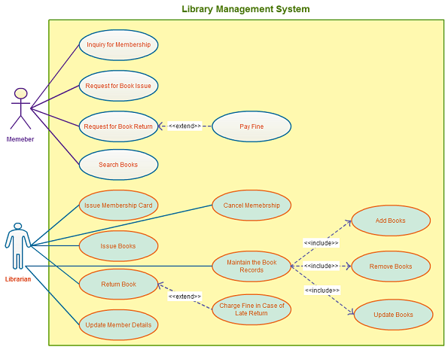

**b)Aim:** Component Diagrams

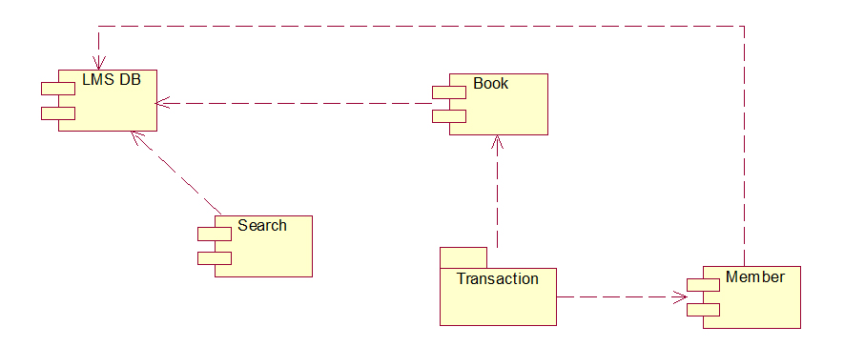

**c) Aim**: Identify relationships between usecases and represent them

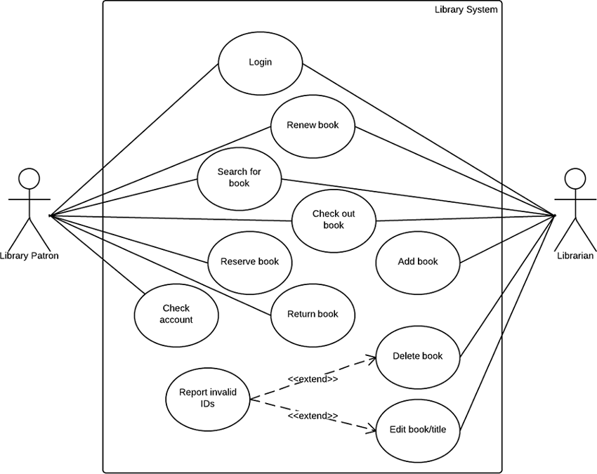

**d) Aim:** Refine Domain Class Model By Showing All The Associations Among Classes

**Association Relationship**: An Association is a connection between classes, showing how oneclass relates to another. The association is shown as a line drawn between the classes. An Association Name can be given to the association to clarify the association between two classes. The name is written on the association line, with an arrow indicating the direction that the association name is to be read, but the association is navigable in both directions.

The following steps are used to refine domain class model.

1. Identify the domain classes to model the problem.
2. Use the association relationship between the domain classes.
3. In the case of inheritance, the generalization relationship is represented between domain classes.

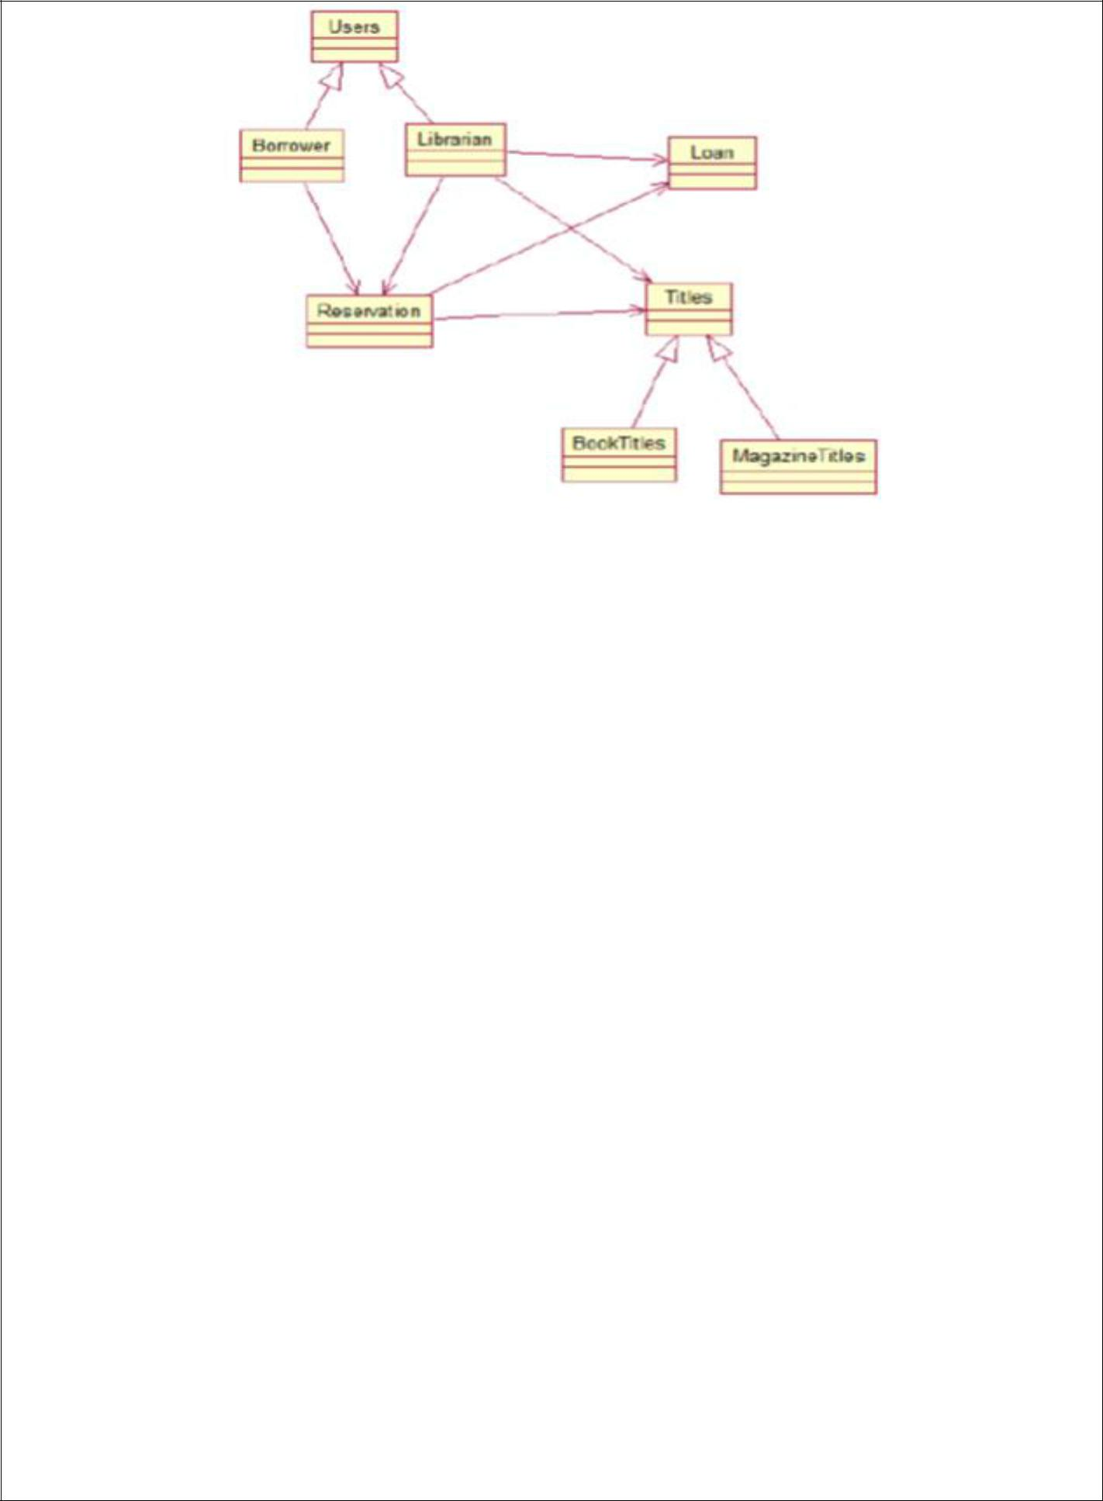

**Result:** The Design was successfully completed.